LAB EXPERIMENT NO # 11
Name: __________________________________ Date: ________________________
Score: __________________________________Signature of Instructor___________
VOLTAGE-CURRENT CHARACTERISTICS OF A JUNCTION DIODE
PERFORMANCE OBJECTIVE:
Upon successful completion of this experiment, the student will be able
- To understand the voltage-current characteristics of a junction diode by using
- Kit (b) Breadboard (c) Electronic workbench (simulation)
EQUIPMENT:
- 0-±15 V Power supply
- Digital Multi Meter
COMPONENTS:
- Electrical Circuit Kit
- A bread board
- IN4001 diode
- 1-KΩ resistor
- Few connecting wires

DISCUSSION:
A diode is a device formed from a junction of n-type and p-type semiconductor materials. The lead connected to the p-type material is called the anode and the lead connected to the n-type material is the cathode. In general, a solid line on the diode, as shown in fig-1-1, marks the cathode of a diode.
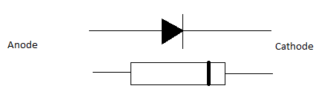
Fig-1-1: The symbol of a diode compared to an actual diode package.

When the positive terminal of diode is connected with positive terminal of battery, this condition allows the current to flow the p-n junction, referred as Forward bias, but when the negative terminal of diode is connected with positive terminal of battery, this condition prevents the current to flow across the p-n junction, referred as Reversed bias. Those two possible conditions are shown in figure 1-2.

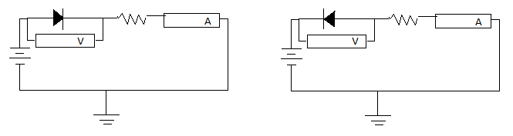
Figure 1-2 (a) Forward Bias Figure 1-2 (b) Reverse Bias
The primary function of the diode is the rectification (process of converting a.c into d.c). When it is forward biased (the higher potential is connected to the anode lead). It will pass current. When it is reverse biased (higher potential is connected to the cathode lead), the current is blocked. The characteristic curves of an ideal and a real diode are seen in Figure 1-3.
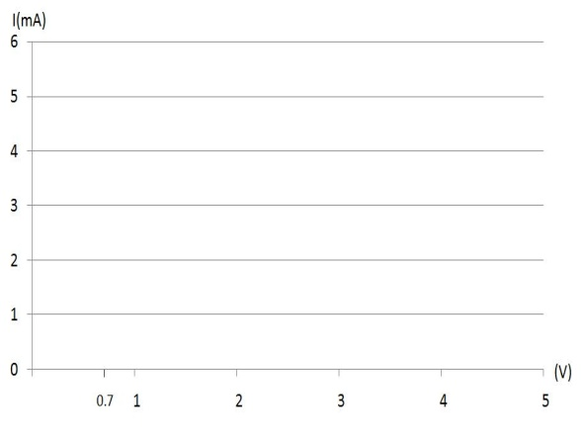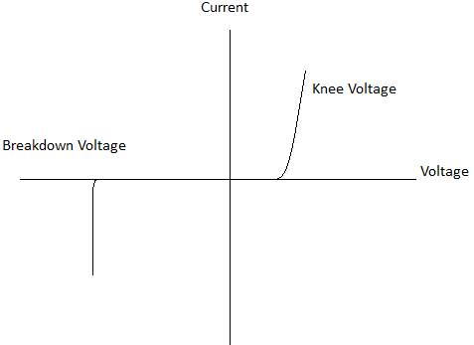

Figure 1-3. Characteristic Curves of an ideal diode and a real diode.

The volt-ampere (V-I) characteristics of a diode show how current (I) in that diode varies with the voltage applies across it experimentally. This can determined by measuring the current in the diode for successive number of higher applied voltage and plotting a graph of current versus voltage, you will note that very little current follows in the diode for low level of the applied voltage. Thus below (0.7V) forward bias, a silicon diode draws little current. For forward bias voltages equal to or higher than 0.7 V, the diode is turn on and permits to current to flow. Beyond 0.7V very slight increases in forward biasing voltages result in the increase of current in the diode dramatically.

The turn on forward bias voltage for silicon diode is typically 0.7V, for germanium it is 0.3V. when the diode is reverse biased, the small current due to minority carriers remain relatively constant, that is independent of the bias voltage up to certain voltage. Beyond this safe level of reverse bias, a phenomenon called “Avalanche Breakdown” takes place when heavy surge of current occurs which may also destroy the diode. The diode must be operated within the safe limit. The limit of the safe operation is specified by the manufacturer under the heading maximum forward voltage (V_{fm}), maximum reverse voltage (V_{rm}) and Peak forward current (I_{fm})

PROCUDURE:

  - Make the circuit as shown in figure 1-2, using the silicon diode (IN 4001) and 1- KΩ resistor on the Kit.
  - Now switch on the power supply and carefully turn the voltage control clock wise whilst watching the ammeter.
  - Set the values of the voltage and observe the values of current. Plot these values on the graph paper. The resulting graph should show the little current passes until the voltage has risen to 0.6V (for silicon), but the current rises rapidly with further increase in voltage.
  - Change the resistor value, repeat all previous steps and fill the observation table.
  - Finally plot the V-I characteristics of diode on graph paper.

OBSERVATION TABLE:

S.No | Voltage (V) | Forward bias (mA) | Voltage (V) | Reverse bias (mA)

REVIEW QUESTIONS:
1. What do you mean by term biasing?
______________________________________________________________________________

2. What is turn on voltage for silicon and germanium at room temperature?
____________________________________________________________________________________________________________________________________________________________

3. What is barrier potential?

______________________________________________________________________________

4. What is the depletion region?
______________________________________________________________________________________________________________________________________________________

5. Whether the forward and reverse characteristics of the diode are verified?
____________________________________________________________________________________________________________________________________________________________

LAB EXPERIMENT NO # 12
Name: __________________________________ Date: ________________________
Score: __________________________________Signature of Instructor___________
HALF WAVE RECTIFICATION
PERFORMANCE OBJECTIVE:
Upon successful completion of this experiment, the student will be able
- To understand the operation of half wave rectification by using
- Kit (b) Breadboard (c) Electronic Workbench (simulation).

EQUIPMENT:
- Oscilloscope
- Digital Multi Meter
COMPONETNTS:
- Electrical Circuit Kit
- A bread board
- IN4001 diode
- 1-KΩ resistor
- Few connecting wires

DISCUSSION:
A rectifier is a circuit that converts pulsing ac into pulsing dc. There are three basic types of rectifier circuits: the half wave, full wave (center tapped) and bridge rectifiers. Of them, bridge rectifier is the most commonly used.
2.1 HALF WAVE RECTIFIER:
Half wave rectification is a process, which converts an ac sinusoidal input voltage into a pulsing dc voltage with the output pulse occurring for each input cycle. The half wave rectifier is made up of a single diode and a resistor (load). The half wave rectifier conducts the current only during the positive half cycle of the ac input supply. The negative half cycle of ac supply is suppressed i.e. during the negative half cycle, no current is conducted and hence no voltage appears across the load. Therefore current always flows in one direction (i.e. dc) through the load after every half cycle.
Operation:
The ac voltage is applied across the secondary windings. During the positive half cycle of ac input voltage point 5 is positive with respect to point 8. This makes the diode D1 forward biased and hence it conducts the current as shown in the upper half cycle of fig.2.1.

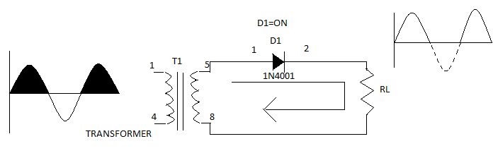
Fig 2.1: Half Wave rectifier
During the negative half cycle, point 5 is negative with respect to point 8. Under this condition, the diode D1 is reverse biased and no current conducts as shown in figure 2.1. Therefore the current flows through the diode during the positive half cycle. In this way, the current flows through the load resistor R_{L} always-same direction. Hence dc output is obtained across the R_{L}. The complete output waveform of half wave rectifier of three cycles will look like as shown in figure 2.2.
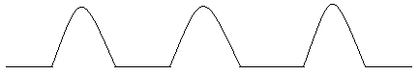

Figure 2.2: Half wave rectifications up to three cycles.

Ripple factor (r):
Ripple factor is very important criteria for measuring the efficiencies of a rectifier. Basically the variations in the output voltage due to charging and discharging is called ripple, as shown in figure 2.3.
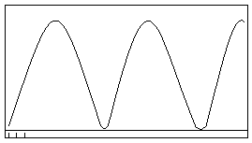
Figure 2.3: Ripple waveform.
it is formally defined as the ratio of ripple voltage in the output voltage delivered to load and the dc component of the output voltage. It is represented by symbol ®.

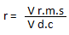

Or alternatively ripple factor can be calculated as
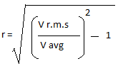
Where Vr.m.s = Vp/√2 ;
While Vavg =Vp/π
Note: Vp denotes the peak value of dc rectified output.
PROCEDURE:
- Make the half wave circuit diagram as shown in fig 2.1
- Observe the rectified output.
- Calculate the ripple factor in each case.
- Observe the ripple on the oscilloscope, using the feature of dc/ac coupling.
OBSERVATION TABLE:

S. No. | (V in) p-p | V out (peak) | V avg= Vp/π | V r.m.s= Vp/ √2 | Ripple factor

REVIEW QUESTIONS:
- What is rectification?
_________________________________________________________________________________________________________________________________________________________________________________________________________________________________
- What is half wave rectification?

______________________________________________________________________________________________________________________________________________________
- What is ripple?
_________________________________________________________________________________________________________________________________________________________________________________________________________________________________
- What are the advantages and disadvantages of half wave rectifier?
_________________________________________________________________________________________________________________________________________________________________________________________________________________________________

LAB EXPERIMENT NO # 13
Name: __________________________________ Date: ________________________
Score: __________________________________Signature of Instructor___________
FULL WAVE RECTIFICATION
PERFORMANCE OBJECTIVE:
Upon successful completion of this experiment, the student will be able
- To understand the operation of full wave rectification by using
- Kit (b) Breadboard (c) Electronic Workbench (simulation).

EQUIPMENT:
- Oscilloscope
- Digital Multi Meter
COMPONETNTS:
- Electrical Circuit Kit
- A bread board
- IN4001 diodes
- 1-KΩ resistor
- Few connecting wires

DISCUSSION:
Alternating current (AC) is generally used throughout the world for powering electrical equipments. As its name implies, an alternating voltage is a voltage which is periodically reversing its polarity and is continually changing its value from instant to instant, as shown in Fig. 3-1(a). Direct current (DC) is commonly used for powering electronic equipments. Reversely, a direct voltage is a voltage which is constant in its value and polarity as shown in Fig. 3-1(b)
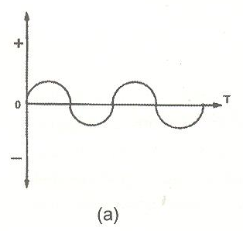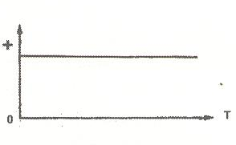
FIG.3-1(a & b) AC &DC voltage waveforms

Since most of electronic equipments, such as radio and TV, are powered by the direct voltage, it is necessary to convert an ac line voltage delivered from a power plant to a dc voltage. The device or circuit which converts the ac voltage to a useful dc voltage is called a rectifier. The functional diagram of a rectifier is shown in Fig. 3-2.

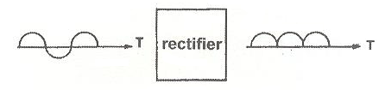
FIG.3-2

There are three types of rectifier circuit commonly used in electronic circuits. They are called a half-wave, full-wave, and bridge rectifier. A half-wave rectifier circuit, is the simplest rectifier for which only half of ac voltage wave is present in the load circuit. On the positive half-cycle of the ac voltage, the diode is forward-biased and conducting, allowing the current to pass through Rl. On the negative half-cycle, the diode is reverse-biased and, therefore, non conducting.
For many applications it is needed to have a rectifier which supplies current during both half-cycles of the ac power voltage and, thus provides a more continuous current to the load. A full-wave rectifier is shown in Fig.3-3. This circuit is essentially two half-wave rectifiers in parallel with inputs that have a phase difference of 180° and usually comes from a center-tapped transformer.
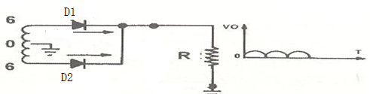
FIG.3-3.Full wave rectifier circuit

A way to obtain full-wave rectification which does not require a center-tapped transformer is shown in Fig. 3-4. This circuit is called the bridge rectifier. On the positive half-cycle, D4 and D5 conduct. On the negative half-cycle, D6 and D7 conduct. In each case, the direction of current flow through the load is the same.
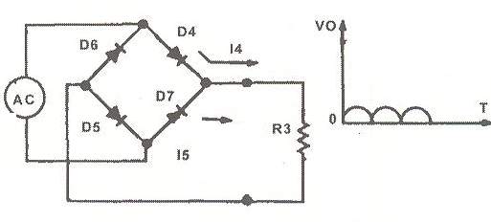
FIG.3-4.Full wave bridge rectifier

Operation:
The ac voltage is applied across the secondary windings. During the positive half cycle of ac input voltage point 5 is positive with respect to point 8. This makes the diode D1 forward biased and hence it conducts the current as shown in the upper half cycle of fig.2.1.

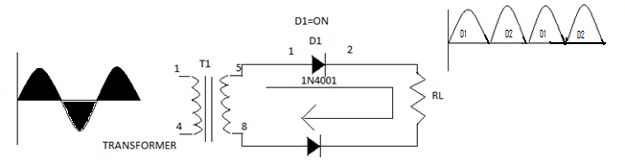
(a) (b) (c)
Fig 3.5: Full Wave rectifier

During the negative half cycle, point 5 is negative with respect to point 8. Under this condition, the diode D1 is reverse biased and no current conducts but diode D2 is forward biased and conducts current. Therefore the current flows during full cycle. In this way, the current flows through the load resistor R_{L} always. Hence dc output is obtained across the R_{L}. The complete output waveform of full wave rectifier of three cycles will look like as shown in figure 2.2.
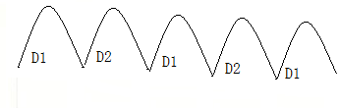
Figure 3.6: Full wave rectifications up to three cycles.

BRIDGE RECTIFIER:
During the positive half cycle of A.C input voltage diodes D4 and D5 are forward biased and conduct current .At this time a voltage is developed across Rl which looks like the positive half of the input cycle. When input cycle is negative, the diodes D6 and D7 are forward biased and conduct current in same direction through Rl as during positive half cycle. During the negative half cycle diodes D4 and D5 are reverse biased. When we combine the output of positive and negative half cycle, the resulting wave looks like as shown in fig. 3.6
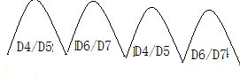
Figure 3.6: Full wave bridge rectifications up to two cycles.
PROCEDURE:
- Make the full wave circuits as shown in fig.3.3 and fig.3.4
- Observe the input and output signals on oscilloscope.
- Calculate the ripple factor in each case.
- Fill the observation table.
OBSERVATION TABLE:
FULL WAVE CENTRED TAPED RECTIFIER
S.NO | Vin(p-p) | Vout(p-p) | Vavg=2Vp/π | Vrms=Vp/1.41 | Ripple Factor

FULL WAVE BRIDGE RECTIFIER
S.NO | Vin(p-p) | Vout(p-p) | Vavg=2Vp/π | Vrms=Vp/1.41 | Ripple Factor
REVIEW QUESTIONS:
- What is full wave rectification process?
________________________________________________________________________________________________________________________________________________

- Compare the two full wave rectifier circuits.
________________________________________________________________________________________________________________________________________________

- Why centre tapped transformer is required with centre tapped full wave rectifier?
________________________________________________________________________________________________________________________________________________

- Which type of rectifier has high ripple factor?
________________________________________________________________________________________________________________________________________________

- What are the advantages and disadvantages of each type of rectifier?
________________________________________________________________________________________________________________________________________________

